**Analysis Conclusions**

The final KNIME workflow is shown below:

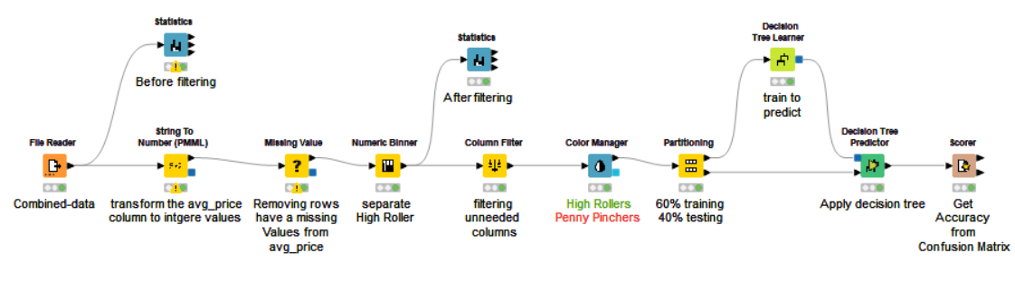

What makes a HighRoller vs. a PennyPincher?

* **The OS “platform_type” that the High Rollers use iOS and the Penny Pinchers use Mac, Win, Android and Linux.**

|  |
| --- |
| **Specific Recommendations to Increase Revenue** |
| 1. **Targeting players who use (IOS) to advertise a specific purchase package customized for them.** |
| 2. **Making Game develop toward ios with special features.** |
| 3. **Designing an advertisement for playing the game, where the game used is filmed on an iOS device.** |